Recover root password in RHEL 7 / CentOS 7

Method 1:

init 6 (or)
Reset OS through VM
Select then e on actual operating system as shown in the image below

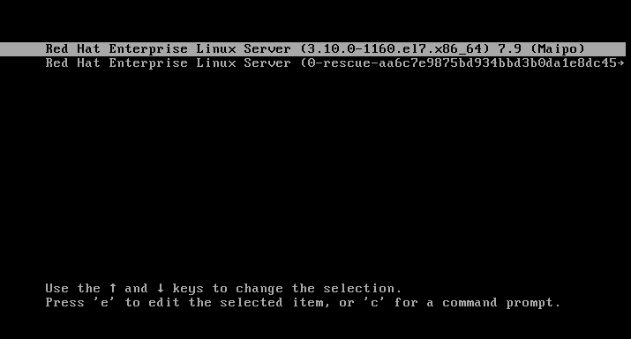

Go to the line of linux 16 and change ro with “rw init=/sysroot/bin/sh”
Ctrl x
chroot /sysroot
passwd root
New password:
Retype new password:
touch /.autorelabel
exit
init 6

Method 2:

init 6 (or)
Reset OS through VM
Select then e on actual operating system as shown in the image below



Go to the line start with linux 16 and write in end of this line "rd.break enforcing=0"
Ctrl x
mount -o remount,rw /sysroot
chroot /sysroot
passwd
New password:
Retype new password:
touch /.autorelabel
exit
init 6

Method 3:

Attach dvd.iso as shown in the image below

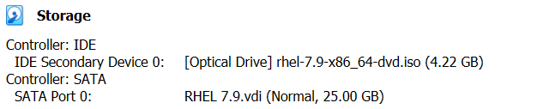

Start the Machine
Press Enter on Troubleshooting mode

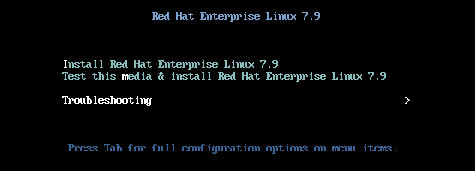

Press Enter on Rescue a Red Hat Enterprise Linux system (Rescue mode)

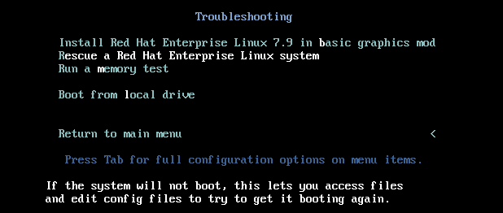

1) Continue 1 Enter

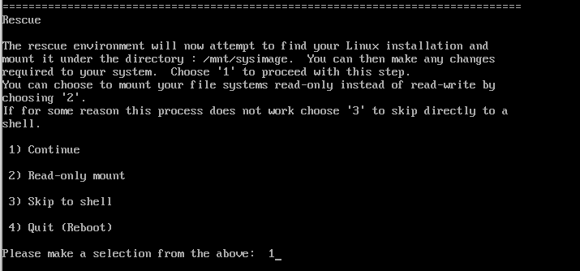

Enter

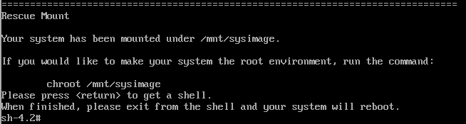

df -h
chroot /mnt/sysimage
passwd root
New password:
Retype new password:
touch /.autorelabel
exit

Remove dvd.iso as shown in the image below

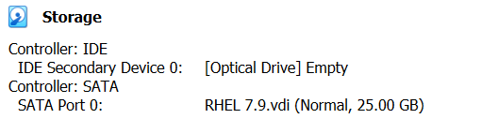

init 6 (or)
Reset OS through VM

